CHAPTER 6
DESIGN
6.1 ARCHITECTURE
6.1.1 LSTM Architecture
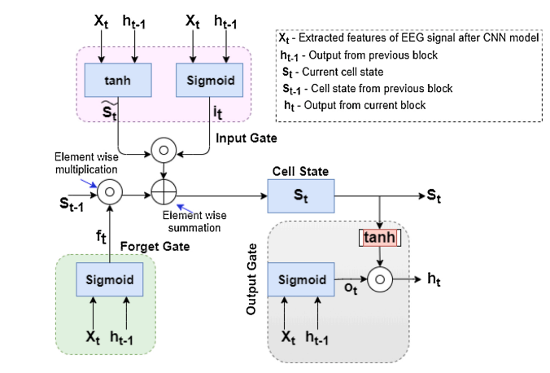
Fig.6.1 LSTM Architecture
An LSTM network processes sequential data such as EEG signals by using a memory cell that can retain information over time. At each time step t, it takes two inputs: the current feature vector Xt (extracted from EEG signals using a CNN) and the previous hidden state ht-1. The forget gate uses a sigmoid function to determine which parts of the previous cell state St-1 should be retained or discarded. The input gate has two components: a sigmoid function that decides which new values to update and a tanh function that generates candidate values to be added to the cell state. These are combined through element-wise multiplication and summation to update the cell state St, which acts as the network’s long-term memory. The output gate then decides what part of the cell state should be passed to the next layer. It uses a sigmoid function to filter the output and a tanh function to scale the updated cell state, resulting in the new hidden state ht. This mechanism allows the LSTM to effectively capture important temporal patterns in EEG data, which is useful for tasks like mental health prediction.
6.1.2 Model Architecture
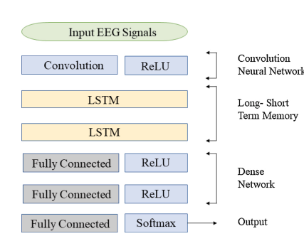
Fig.6.2 Model Architecture
The process begins with raw EEG signals as input. These signals are first passed through a convolutional layer, which extracts important spatial features from the EEG data. The ReLU (Rectified Linear Unit) activation function follows the convolution to introduce non-linearity and help the model learn complex patterns. The extracted features are then passed into two stacked LSTM layers. LSTMs are well-suited for sequential data like EEG because they can retain temporal dependencies and long-term relationships across time. These layers help the model understand how brain signal patterns change over time, which is crucial for detecting depression-related patterns.
After the LSTM layers, the output are fed into a series of fully connected (dense) layers. The first two dense layers are each followed by a ReLU activation function, which helps the network model more abstract and non-linear relationships in the data. The final fully connected layer ends with a Softmax activation, which outputs the probability distribution across different classes for example, "depressed" or "not depressed".

6.2 FLOW CHART

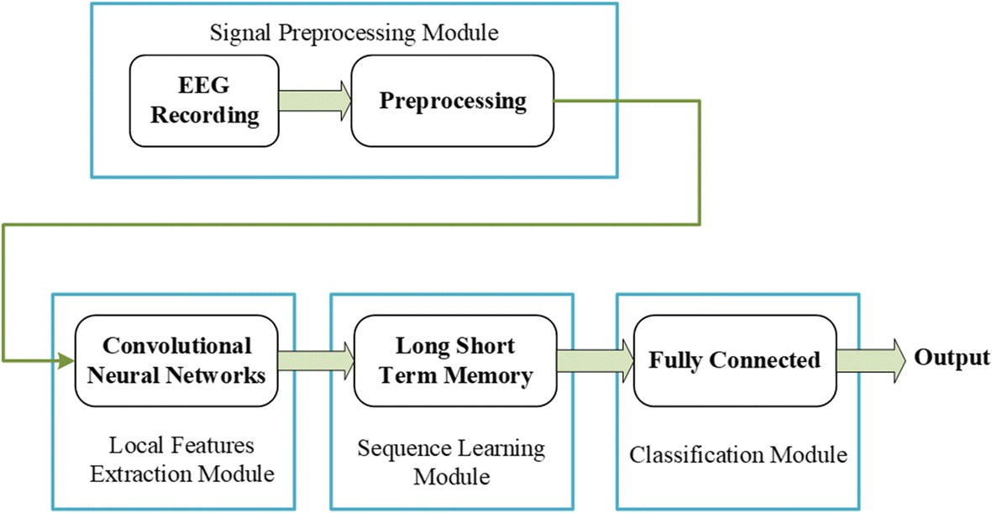
Fig.6.3 Flow Chart
The process starts in the Signal Pre-processing Module, where raw EEG signals are filtered, cleaned of artifacts, and normalized for consistency. These processed signals are passed into a Convolutional Neural Network (CNN), which extracts spatial features from different brain regions. The extracted spatial data is then fed into a Long Short-Term Memory (LSTM) network that captures temporal dependencies, analyzing how brain activity evolves over time—an important factor in identifying depression.
The output from the LSTM is passed to a Fully Connected layer for classification, which predicts whether the subject is depressed or not. This deep learning pipeline removes the need for manual feature engineering and allows the system to automatically learn meaningful patterns. Techniques like dropout and batch normalization are used to improve model generalization and stability. The model is trained using binary cross-entropy loss and optimized with the Adam optimizer for efficient learning.
Multiple EEG segments across various frequency bands are analyzed, and the final output uses a sigmoid activation to produce depression probabilities. This architecture is not only accurate but also scalable and adaptable for other mental health conditions, making it a promising tool in clinical diagnosis and neuropsychiatric research.
6.3 USE CASE DIGRAM
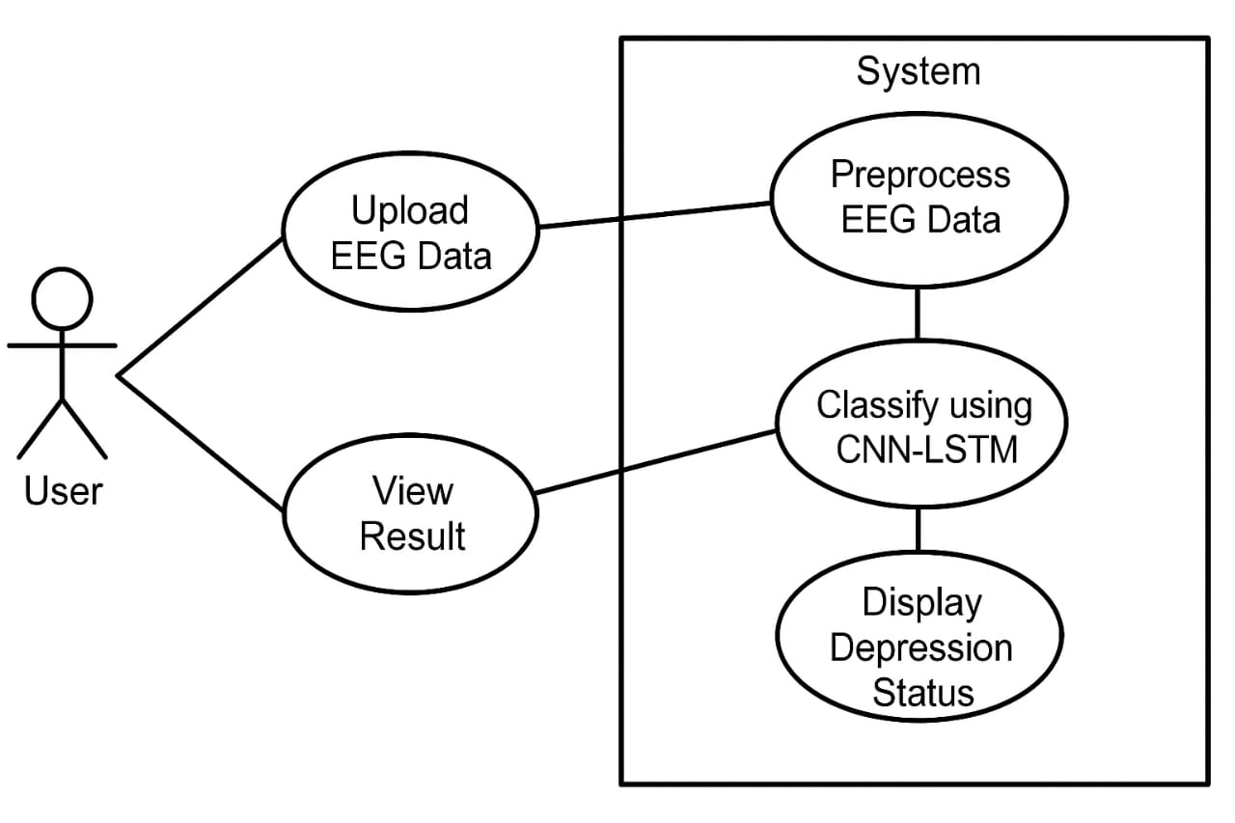
Fig.6.4 Use Case Diagram
To enhance accuracy, the system may also include artifact removal techniques such as eliminating eye blinks or muscle movement interference. The segmentation process divides the EEG signals into meaningful time windows, enabling the model to focus on short, relevant signal intervals. During feature extraction, the CNN learns spatial patterns from different electrode positions across the scalp, identifying region-specific activity. The LSTM then processes these features sequentially, capturing the progression and temporal shifts in brain activity linked to depressive symptoms. The combined CNN-LSTM architecture ensures that both spatial and temporal characteristics of the EEG signals are thoroughly analyzed. Post-classification, the output is interpreted using a sigmoid activation function to provide a clear probability score indicating the presence of depression. The results can optionally be stored or exported for further clinical analysis or longitudinal tracking.
For improved performance, the model can be trained on a large, labeled dataset containing EEG recordings from both depressed and non-depressed individuals. The system may support real-time or batch processing modes, depending on the application needs. Additionally, user authentication and data privacy measures can be integrated to ensure secure handling of sensitive health information.

6.4 ACTIVITY DIAGRAM
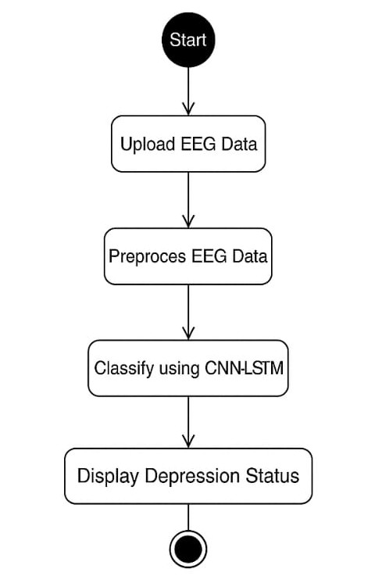
Fig.6.5 Activity Diagram
The system begins when the user initiates the process by uploading EEG data. The uploaded EEG signals are then received by the system and passed through a pre-processing stage, which involves cleaning the signals, removing artifacts, and normalizing the data to ensure it is suitable for analysis. Pre-processing also includes segmenting the signals into shorter time windows, which improves the efficiency and precision of feature extraction.
Once pre-processing is complete, the cleaned EEG data is fed into a CNN-LSTM-based classifier. The Convolutional Neural Network (CNN) extracts spatial features from the signals, identifying relevant patterns across different electrode positions on the scalp.
To enhance performance, regularization techniques such as dropout may be applied within the model to prevent overfitting. The classifier’s final layer typically uses a sigmoid activation function to generate a probability score, which indicates the likelihood of depression. Based on this analysis, the system classifies the input and displays the depression status to the user. This final output indicates whether signs of depression are detected in the EEG data, completing the process in a clear, automated, and user-friendly manner.
  - ALGORITHMS
6.5.1 Convolutional Neural Network (CNN) Module
Purpose: Extracts spatial and temporal features from EEG signal segments.
Algorithm:
- Start.
- Receive pre-processed EEG time-series input.
- Apply convolutional operation:
  - Slide filters (kernels) over the signal.
  - Capture patterns from EEG signal windows.
- Use ReLU activation to introduce non-linearity:
  - For each value xxx:
    - If x>0x > 0x>0, return xxx.
    - Else, return 0.
- Generate feature maps representing extracted EEG features.
- Pass feature maps to the LSTM module.
- End.
The Convolutional Neural Network (CNN) module is responsible for extracting meaningful spatial and temporal features from pre-processed EEG signal segments. Initially, the CNN receives the cleaned EEG time-series data as input. Convolutional filters (kernels) are then applied by sliding over the input signal to detect local patterns within the EEG windows. These filters help in identifying relevant signal characteristics that are critical for accurate classification.
Following the convolution operation, a ReLU (Rectified Linear Unit) activation function is applied to introduce non-linearity into the network. ReLU enhances the model’s ability to learn complex relationships by retaining only positive values and converting all negative outputs to zero. The output of this process is a set of feature maps that highlight important features extracted from the EEG data. These feature maps are then forwarded to the LSTM module for further sequential analysis. This step effectively transforms raw EEG signals into a structured feature representation, enabling more accurate classification of depression-related patterns.
    - Long Short-Term Memory (LSTM) Module
Purpose: Learns sequential dependencies and temporal dynamics from EEG features.
Algorithm:
- Start.
- Receive CNN-generated feature maps.
- For each time step t in the sequence:
  - Compute Forget Gate ft
  - Compute Input Gate it
  - Compute Candidate Memory Ĉt
  - Update Cell State Ct
  - Compute Output Gate ot and Hidden State ht
- Pass hidden state to the fully connected layers.
- End.
The Long Short-Term Memory (LSTM) module is designed to capture sequential dependencies and temporal dynamics from the feature maps generated by the CNN module. It processes the input as a time-series sequence, learning how the EEG signal patterns evolve over time, which is crucial for accurate depression detection.
The module begins by receiving the CNN-extracted feature maps. For each time step in the input sequence, the LSTM performs several internal operations: the forget gate decides which information from the previous cell state should be discarded; the input gate determines which new information should be added to the cell state; the candidate memory generates potential new values to update the cell state. These components work together to update the cell state, which acts as the long-term memory of the model. Then, the output gate uses the updated cell state to compute the hidden state, which captures the relevant information for the current time step. This hidden state is passed to the fully connected layers for the final classification. This process enables the system to understand and retain important temporal features in the EEG data for effective depression prediction.
    - Adam Optimizer with Huber Loss
Purpose: Optimize the hybrid model using adaptive learning rate.
Algorithm:
- Start.
- Initialize weights and training parameters.
- Set:
  - Batch size = 64
  - Epochs = N
  - Loss function = Huber Loss
  - Optimizer = Adam
- For each epoch:
  - Perform forward pass.
  - Compute Huber Loss:
  - Backpropagate error.
  - Update weights using Adam.
- End.
The model uses the Adam optimizer in combination with the Huber loss function to effectively train the CNN-LSTM network for depression detection using EEG signals. This setup ensures stable and efficient optimization, particularly when dealing with noisy or outlier-prone EEG data.
The training process begins by initializing the network's weights and setting the training parameters. The batch size is set to 64, and the model is trained over a defined number of epochs (N). The Huber loss function is chosen as the loss metric because it is less sensitive to outliers compared to mean squared error, making it suitable for real-world EEG data. During each epoch, a forward pass is performed to generate predictions from the input data. The Huber loss is then calculated by comparing the predicted output with the true labels. The error is backpropagated through the network, and the Adam optimizer adjusts the model weights using an adaptive learning rate strategy. This process continues iteratively until the model converges, ensuring both accuracy and robustness in classification.
    - Fully Connected Neural Network (FCNN) Module
Purpose: Classifies EEG signal into depressed or normal class.
Algorithm:
- Start.
- Receive LSTM output.
- Pass through Dense Layer 1 (ReLU).
- Pass through Dense Layer 2 (ReLU).
- Pass through Output Layer (Softmax).
- Output predicted class (0 = Normal, 1 = Depressed).
- End.
The Fully Connected Neural Network (FCNN) module serves as the final classification stage in the depression detection system. Its primary purpose is to classify the EEG signal into one of two categories: normal or depressed, based on the temporal features learned by the LSTM module.
The module begins by receiving the output from the LSTM layer, which contains the relevant sequential features extracted from the EEG data. This output is first passed through Dense Layer 1 followed by a ReLU activation function, which introduces non-linearity and allows the network to learn complex patterns. The transformed output is then passed through Dense Layer 2, again using a ReLU activation to further refine the feature representation. Finally, the data is passed through the Output Layer, which uses a Softmax activation function to generate a probability distribution over the two classes. The class with the highest probability is selected as the final prediction, where 0 represents a normal condition and 1 indicates depression. This module effectively maps the high-level features into a clinically meaningful classification output.

